**CSE100 Project: Employee Management System**

**Design Document**

# TEAM DETAILS

|  |  |  |  |
| --- | --- | --- | --- |
| **RollNo** | **Name**  **(Firstname Lastname)** | **Email Id** | **Contact No.** |
| **AU2140088** | **Buland Shah** | **buland.s@ahduni.edu.in** |  |

**[1] PROBLEM DEFINITION**

|  |  |
| --- | --- |
| **Title of the project** | Employee Management System |
| **Objective/vision/main goal** of developing the software  application | To create a database system that stores important data of the employees. It also allows manipulation and addition/deletion of data for the purpose of keeping records. |
| **What Problem will be solved by the proposed software application** (or real-life need/use of the software application) | As real-world application, the software will help in digitization of numerous data. So instead of storing physical copies, data can be stored and maintained easily in the form of soft copies.  Furthermore, as the data is digitized it makes way for easier and enhanced data manipulation and analysis of the records for the company/organization. |
| **End-Users of the software:** different types of users/roles who are going to use the software like admin, customers, manager, employee, etc. | The targeted users for Employee Management Software are admins, managers who are responsible for keeping track of the employee records.  However, employees can be allowed to use software under certain restrictions like they can see the records without any manipulation or modification of data. |
| **Listing of**  **functionality/features/main modules** to be provided in the software to different end-users | Following are pre-visualized functionalities provided by the software :  1.) View the employee data table.  2.) Add a new employee record.  3.) Update a specific employee record.  4.) Delete employee record/records.  5.) Save changes and exit. |
| **Important System-outputs to be generated from the software** | The software will show the employee data table as output, including data that has being changed last time.  Furthermore, after saving of changes to table, a .txt/.dat file will be created storing all records. |

**[2] PROJECT DESIGN**

**2.1 User Interface Design** - Design of Menus, Input and Output Screens

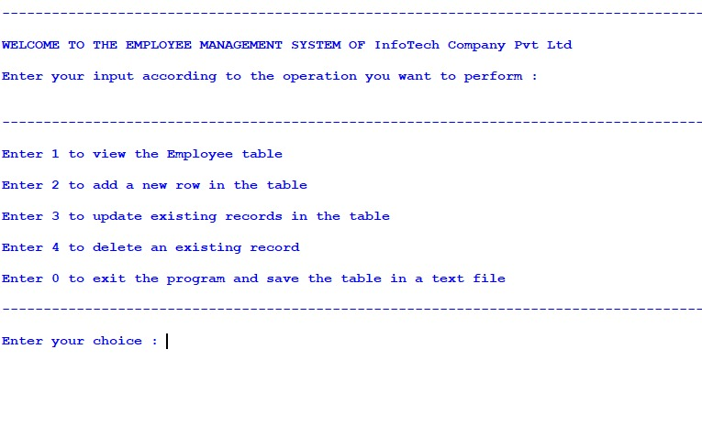

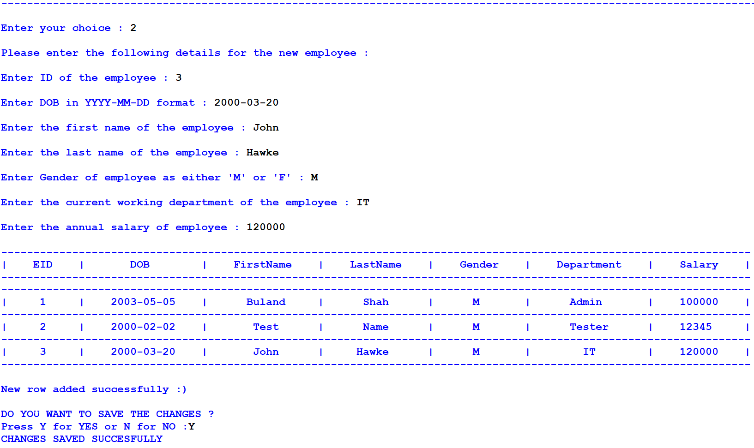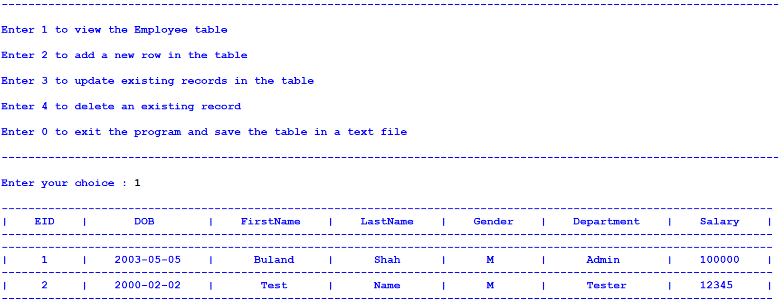

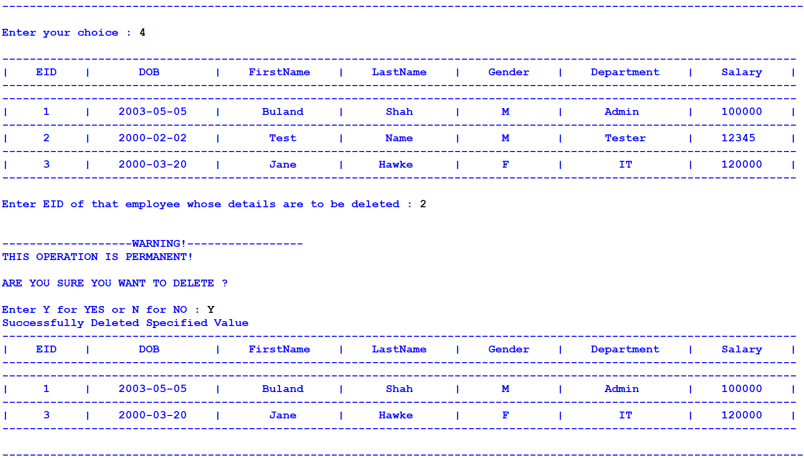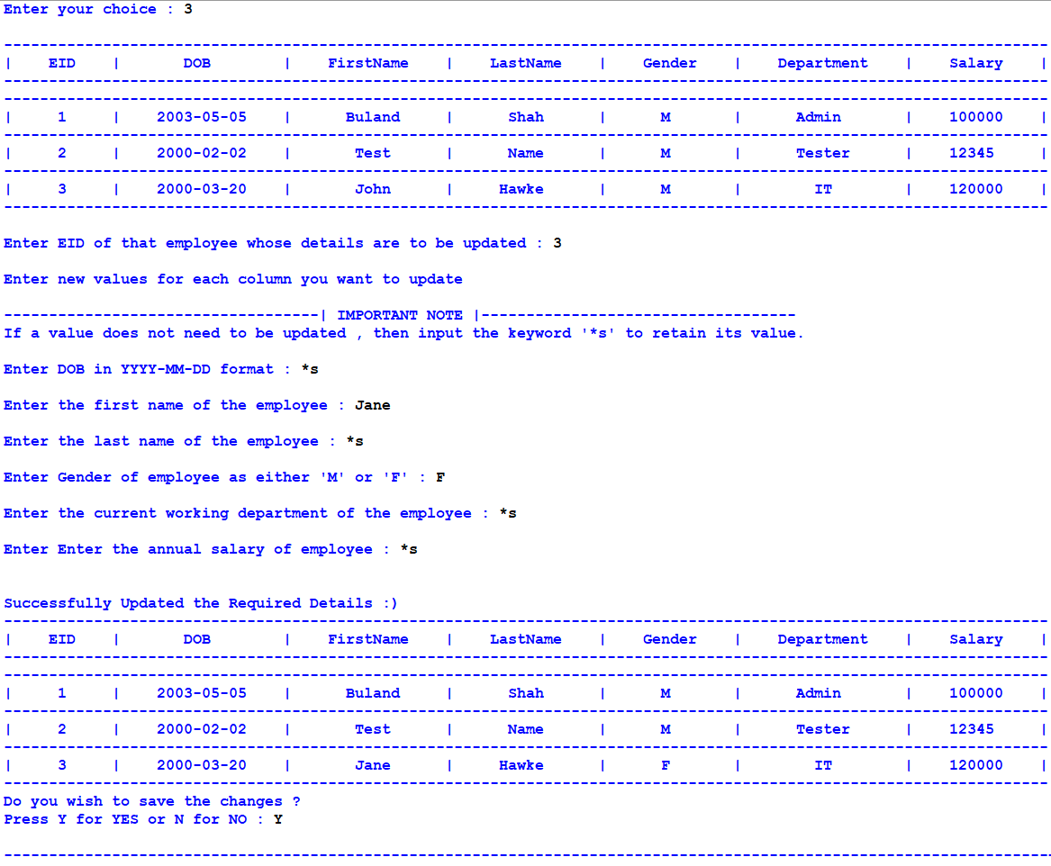

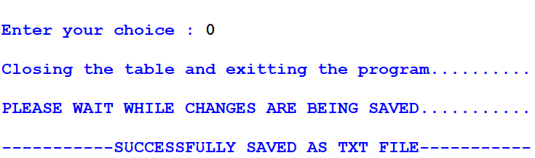

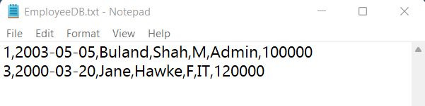

## 2.2 Database Design

* The program uses a data file in order to retrieve the records saved in it. After each successful data manipulation, the file saves the latest data.
* The filename and design will be as follows:
* **EmployeeDB.txt**

